Senior Cadet Captain, Sohail Qureshi participated in the RDC camp, 2019.
Senior Cadet Captain Aditi Upadhyay, represented 48 Assam Naval Unit in Rajpath and PM Rally in Republic Day Camp, 2021. She got the title of ‘BEST CADET’ also.
DELHI DG NCC CAMP (01st to 28th January, 2022)
PO CADET JAVED AHMED, participated in the RDC camp held at New Delhi from 18th Dec to 29th Jan, 2022 representing North East Directorate.

PO Cadet Biswajit Deka, attended the Overseas Deployment (OSD) 2022. His camp duration was for 30 days. The entire camp was attached to Indian Coast Guard Ship “SARATHI”. He got the opportunity to visit four countries: Dubai (UAE), Kuwait City, Oman (Muscat) and Bandar Abbas (Iran).

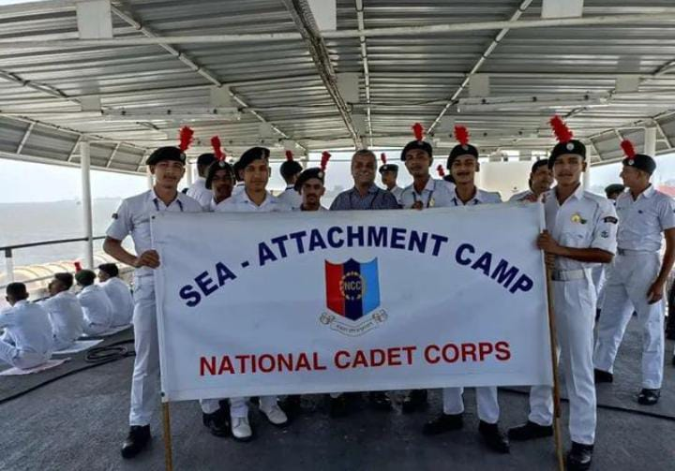
SEA ATTACHMENT CAMP
WNC MUMBAI
30th APRIL to 10th MAY, 2022
CADETS: CC AMARJYOTI BHAGAWATI
CADET DEEP BURAGOHAIN
CADET ROCKTIM BORGOHAIN
CADET RITUPON BHARALI
CADET SUMAN KUMAR RAY
CADET YUVRAJ CHETRI

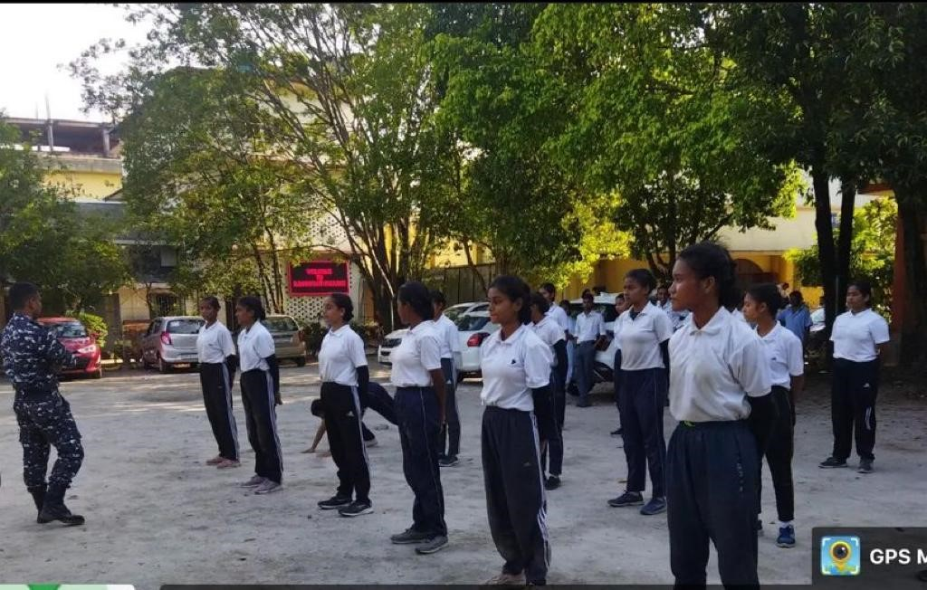

Selection for New Enrolment, 2022 by Respected Debananda Doley Sir, Commanding Officer, 48 Assam Naval Unit, NCC at B. Borooah College.

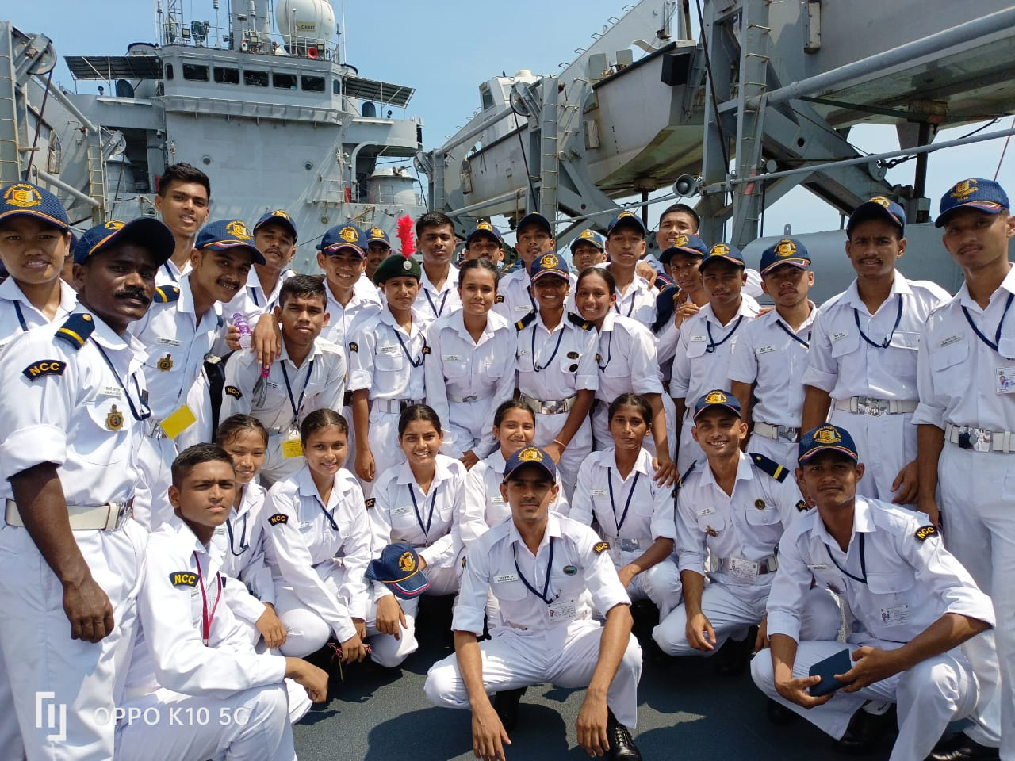
ALL INDIA NAU SAINIK CAMP
VIZAG, VISHAKHAPATNAM
02nd to 12th OCTOBER, 2022
NAMES OF THE CADETS: CC AMARJYOTI BHAGAWATI
CADET BISHAL SHAH
PO CADET KRITIKA SHARMA
CADET NIRAJ KUMAR BHARTI
L.CADET ARPITA SAIKIA DAS
TEAM OF BOAT PULLING AND EXTRA CURRICULAR ACTIVITIES

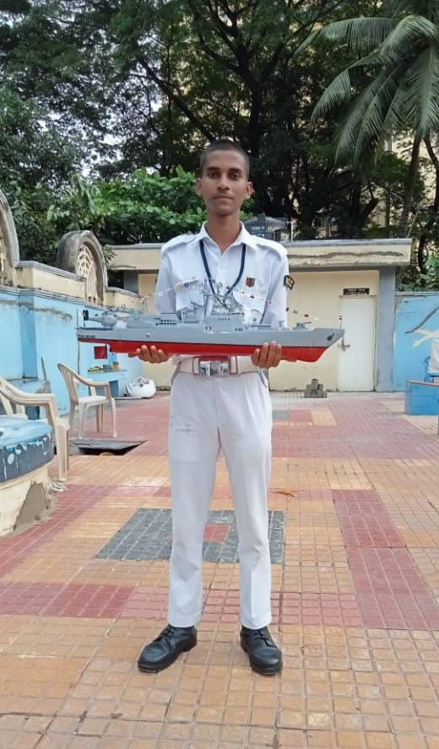
ALL INDIA NAU SAINIK CAMP
02nd to 12th OCTOBER, 2022
SHIP MODELLER OF 48 ASSAM NAVAL UNIT, NER DIERECTORATE
CADET SUMIT SHARMA

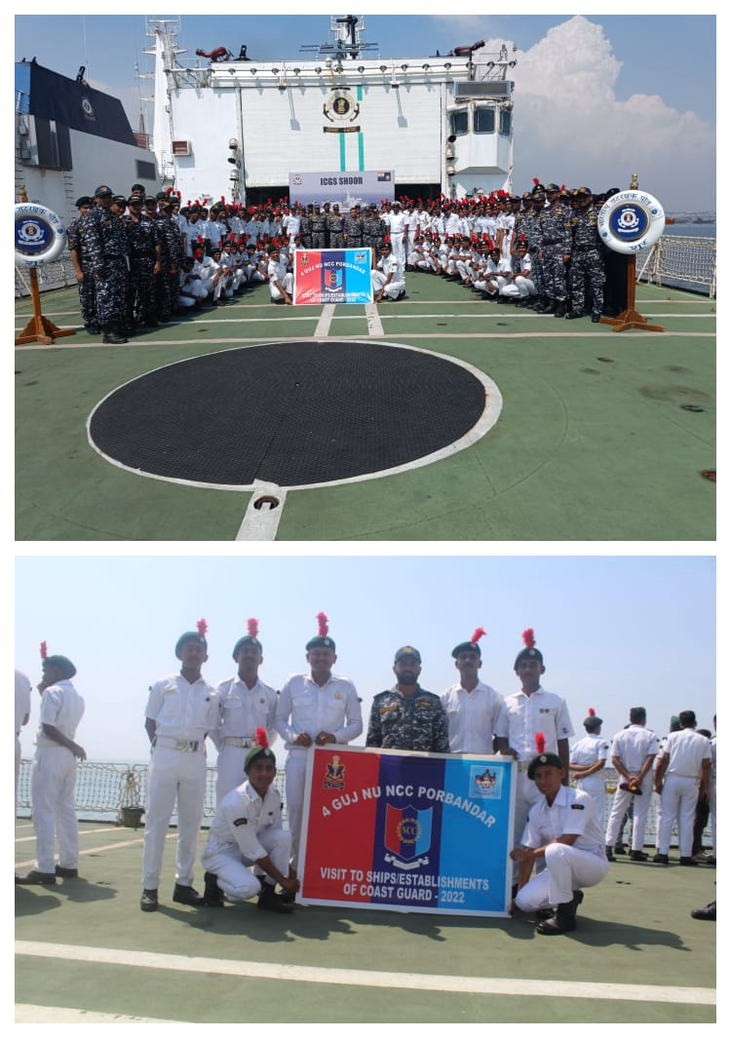
SHIP ATTACHMENT/COAST GUARD ESTABLISHMENT
PORBANDAR, GUJARAT
07th to 15th OCTOBER, 2022
CADETS: L. CADET CHOTU YADAV
CADET RAHUL URANG

Also visited ICGS Shoor Ship for 1 Week, Coast Guard Air Enclave Station, and had a Visual of Fighting Jat, Radar.

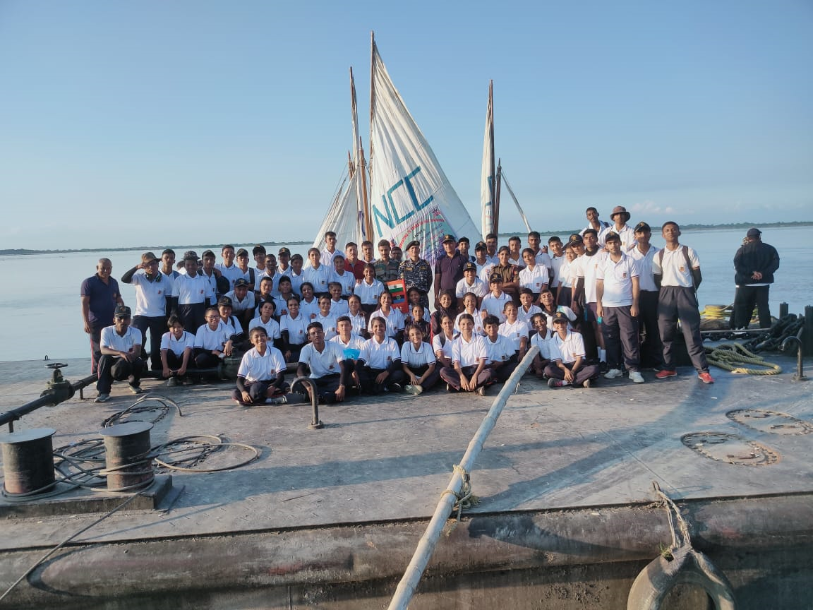
THE BRAHMAPUTRA RIVER SAILING EXPEDITION CAMP, MENU 2022
BISHWANATH GHAT TO PANDU
09th to 26th OCTOBER, 2022
CADETS: L CADET SANSKRITI KUMARI
CADET PRANJAL RAJBONGSHI
CADET RIMJHIM HAZARIKA
Team of boat pulling, sailing, street show regarding issues of women empowerment and acid attack, etc.

SEA ATTACHMENT CAMP
12th to 23rd December, 2022
CADET AMIT SHARMA & CADET ABHISHEK DEY

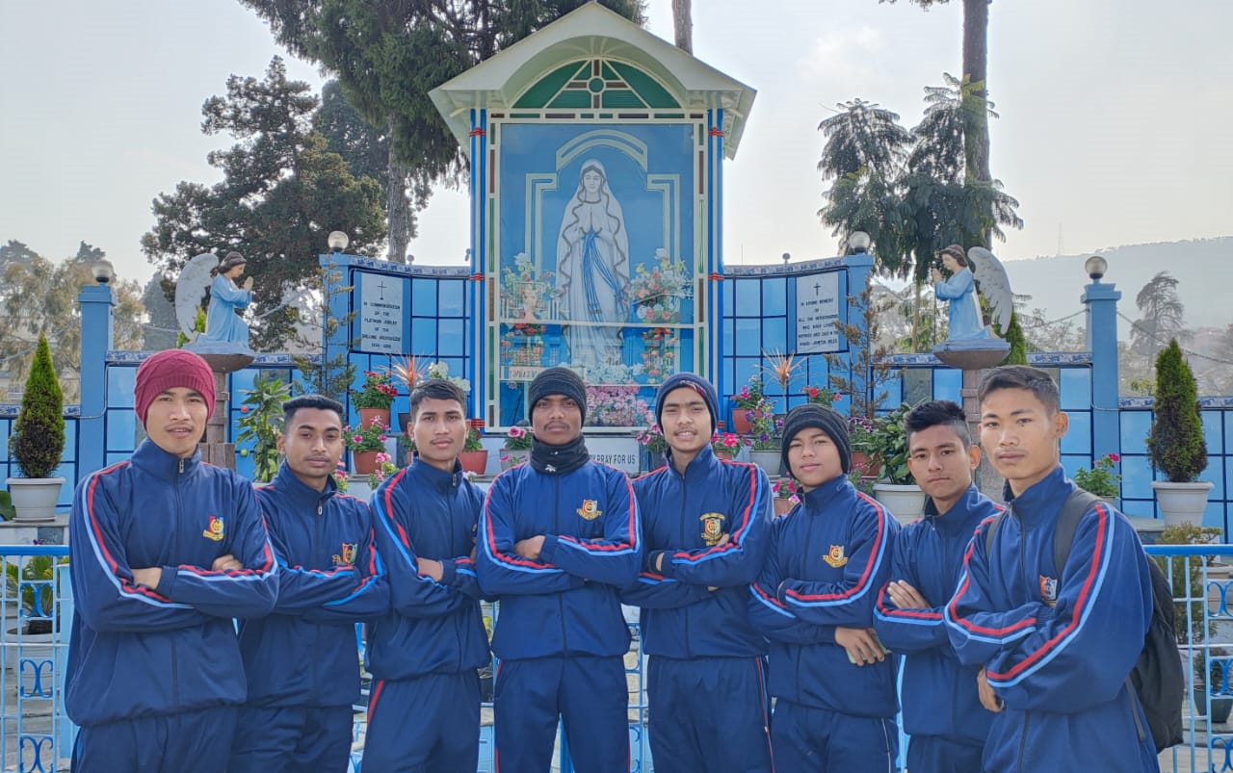
ALL INDIA TREKKING EXPEDITION, NER TREK – I
NEHU, SHILLONG
10th TO 17th JANUARY, 2023
CADET: SAURABH PEGU
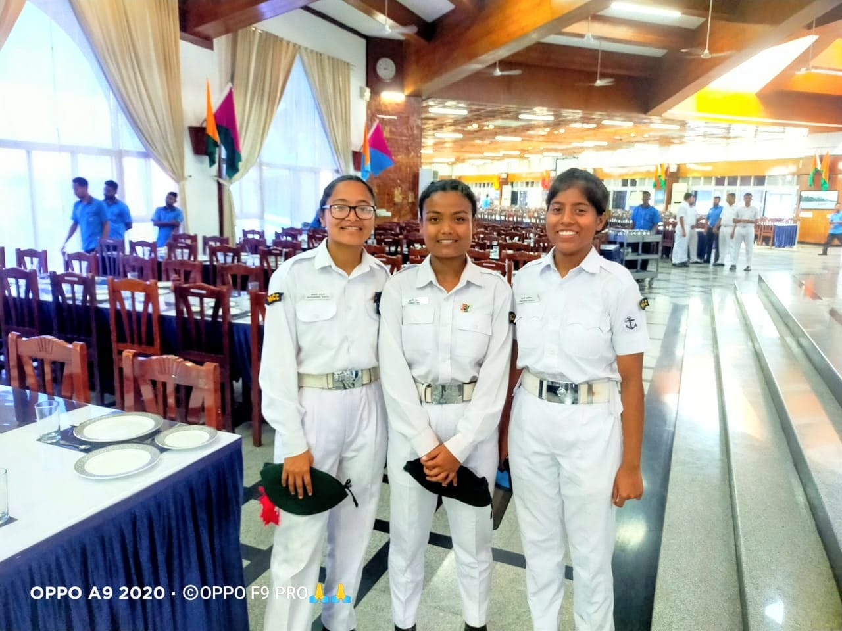
ALL INDIA ANNUAL TRAINING CAMP
INA KERALA, EZHIMALA
09th to 20th JANUARY, 2023
CADET: L. CADET SURAVI DAS

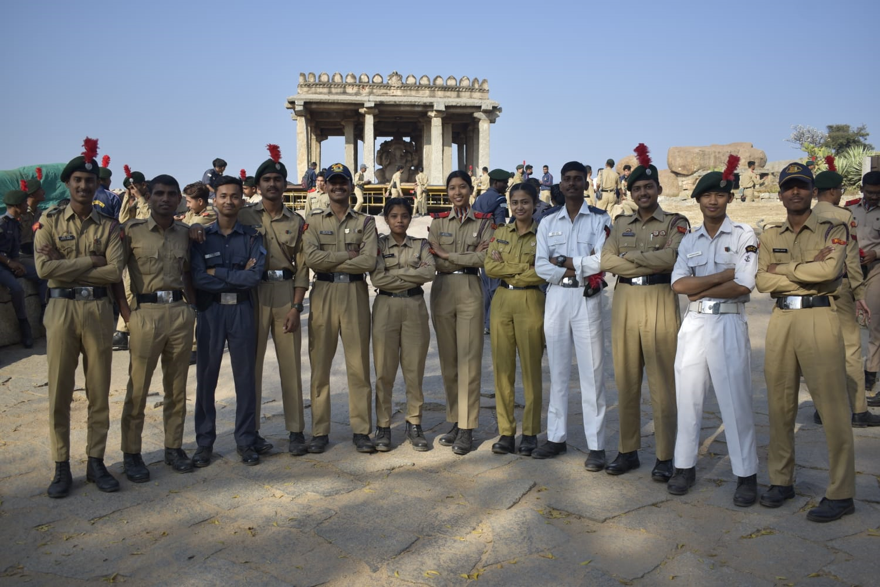
EK BHARAT SRESTHA BHARAT CAMP (EBSB – II)
KARNATAKA AND GOA
16th to 26th JANUARY, 2023
CADET: L. CADET JWNGSAR DEURY

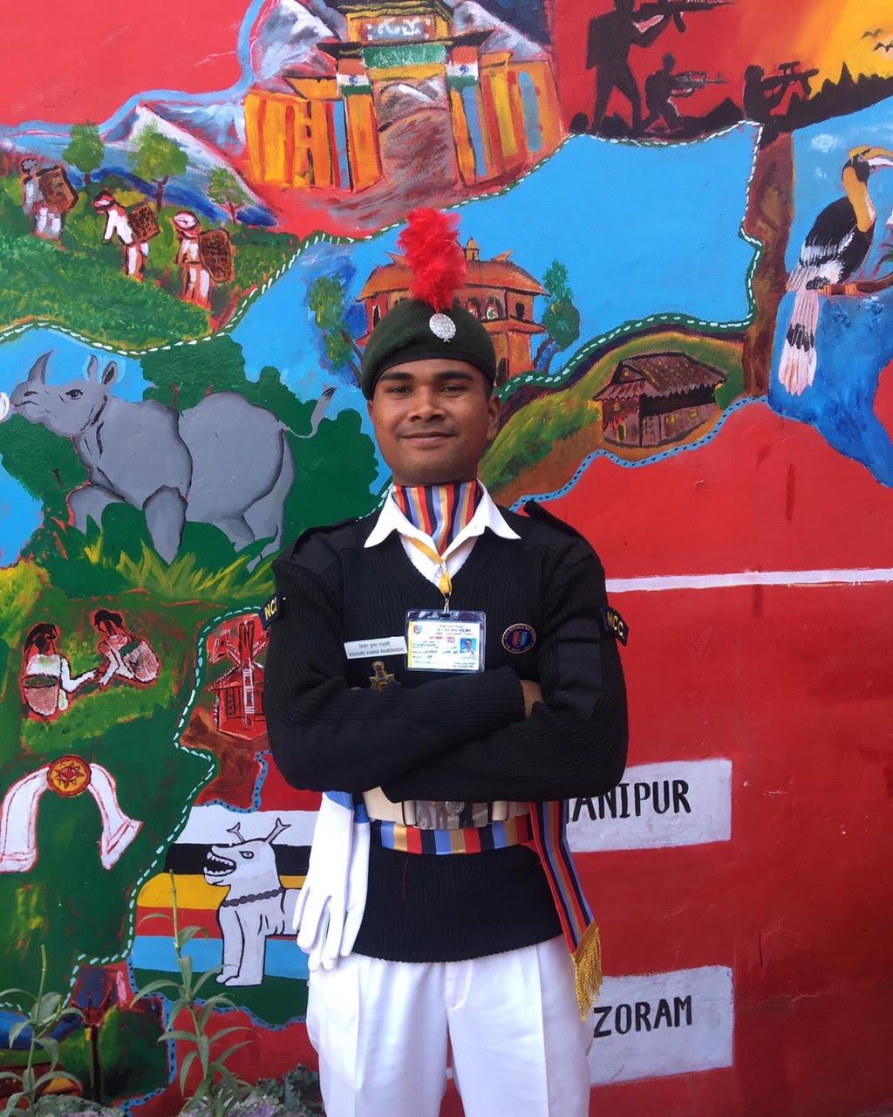
REPUBLIC DAY CAMP, 2023
NEW DELHI
Got the title of “BEST CADET” in the camp and “YEP CADET” from New Naval Wing
CADET: L. CADET KISHORE KUMAR RAJBONGSHI

PO Cadet Kritika Sharma got the title of Best Ship Modeler 2023 of 48 Assam Naval Unit.

